CSA1103 00AD-LAB PRACTICE P.Gayathri(192321169)

Question 4: ATM Banking System – Scenario: A bank plans to redesign its ATM software. Customers insert their ATM cards, enter PIN numbers, select banking services, perform transactions, and receive printed receipts. Invalid PIN attempts are limited to three. Cash is dispensed only after sufficient balance verification. Every transaction updates the database immediately. Customers can also check account balance and transfer funds. Failed transactions display appropriate error messages. Security and transaction logging are mandatory. The bank requires a workflow representation before implementation.
USE CASE DIAGRAM:
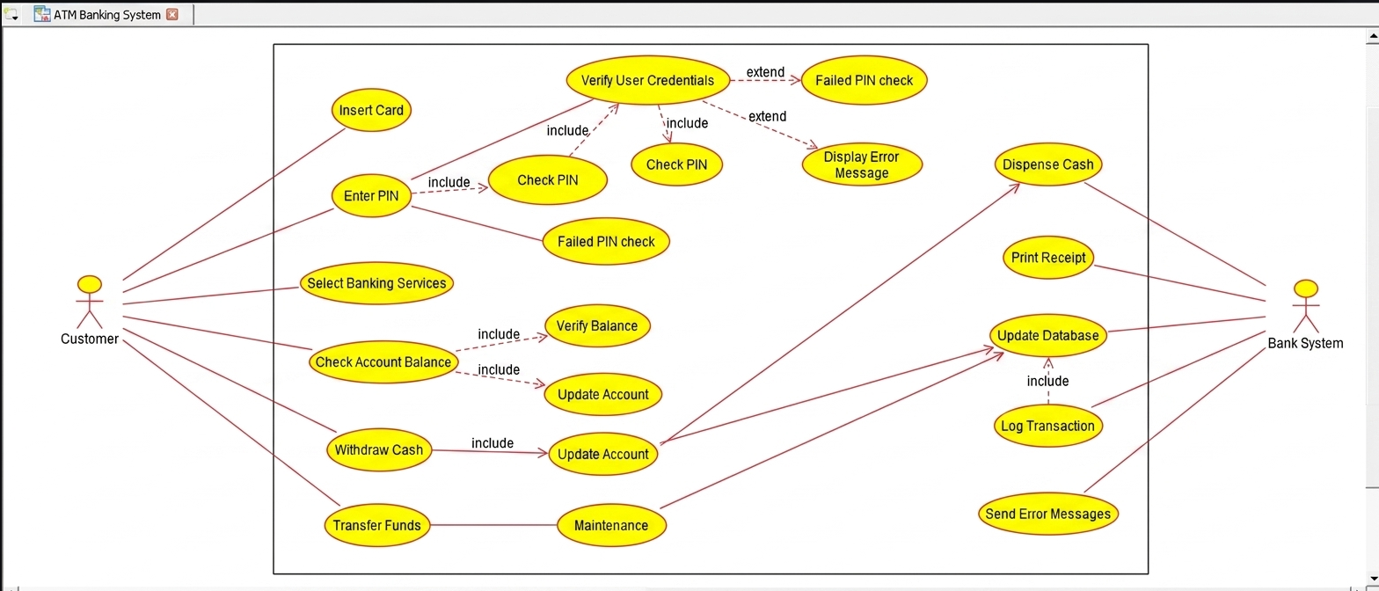
CLASS DIAGRAM:
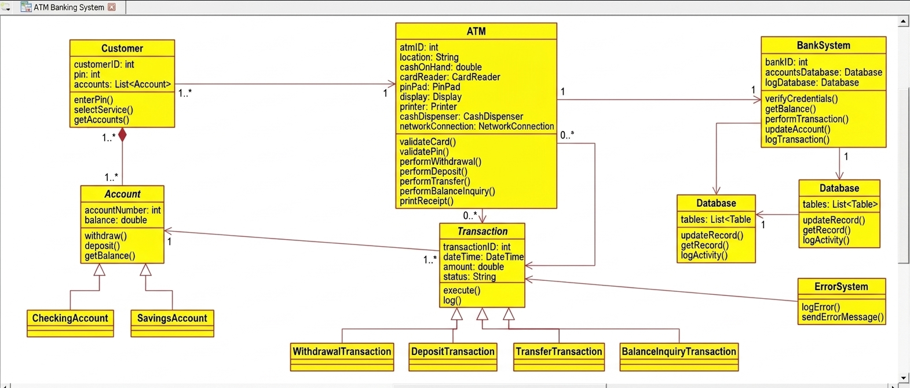

ACTIVITY DIAGRAM:
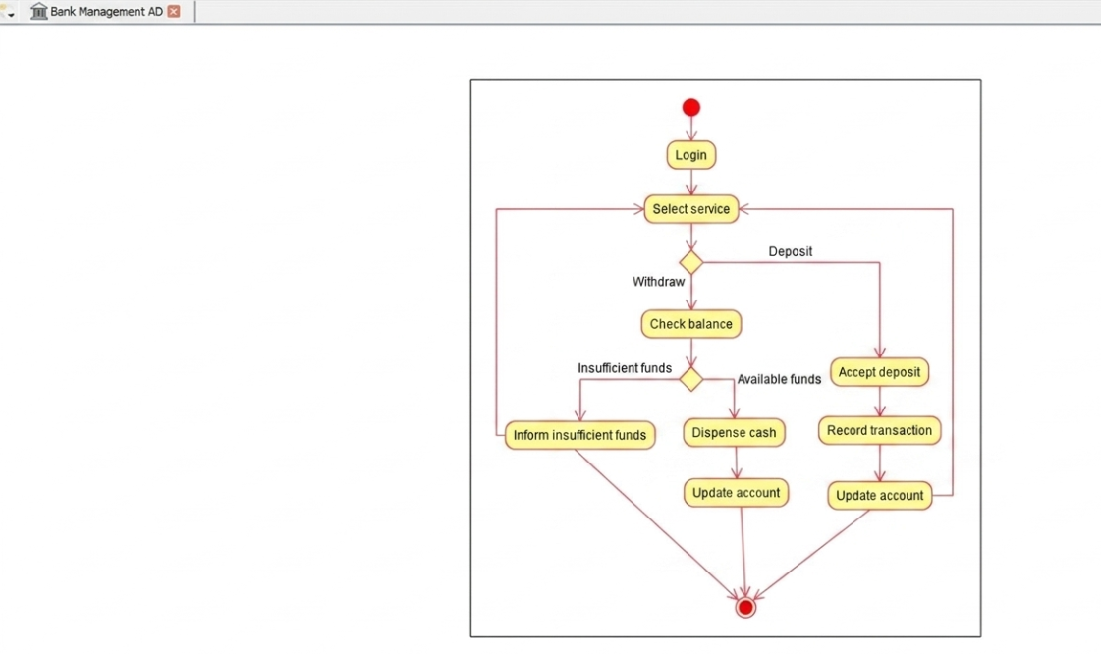
DEPLOYMENT DIAGRAM:
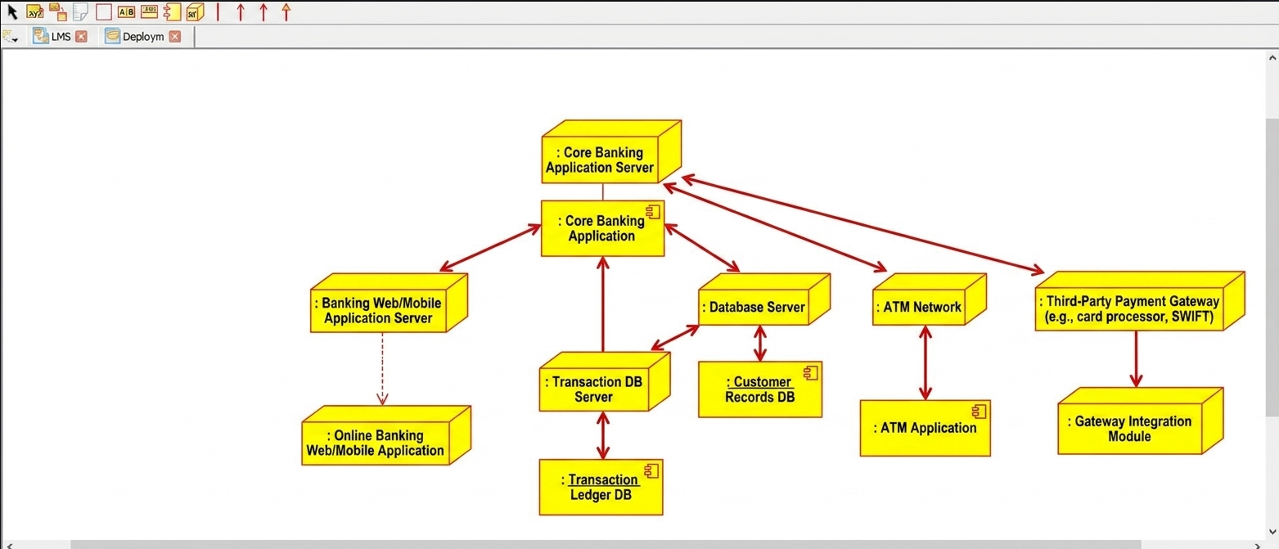
SEQUENCE DIAGRAM:
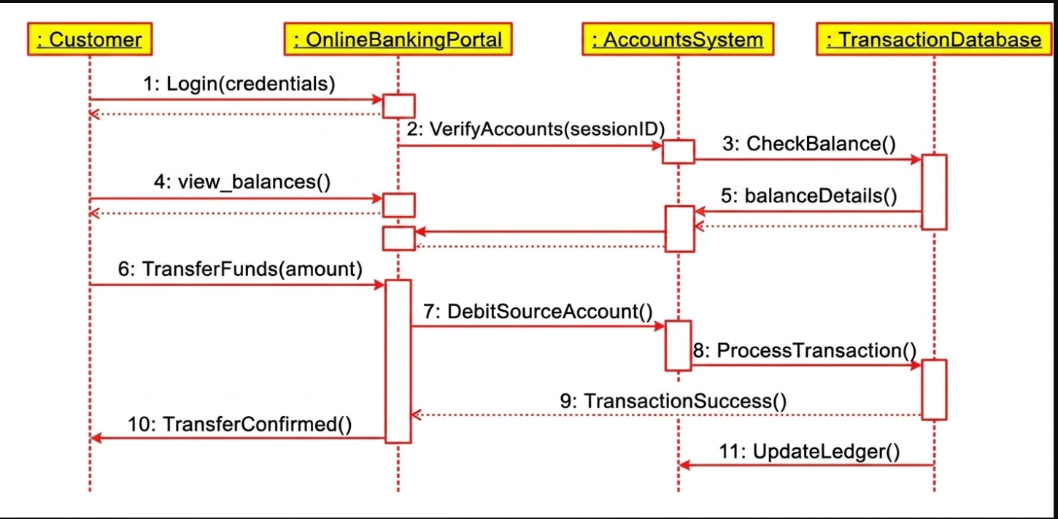

STATE MACHINE DIAGRAM:
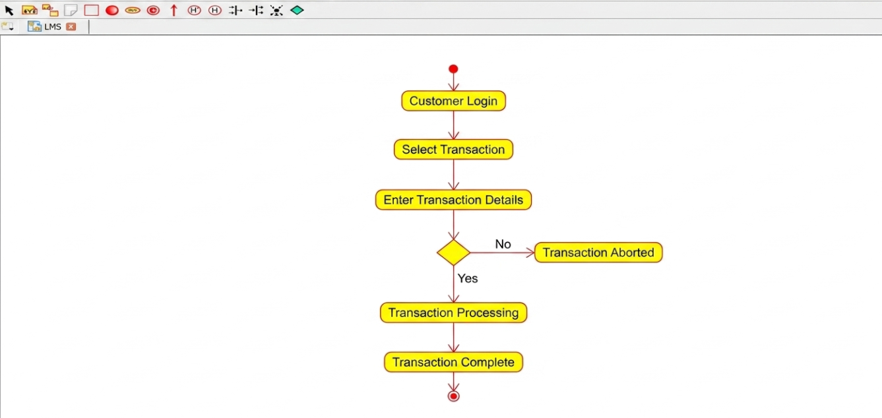
COMPONENT DIAGRAM:
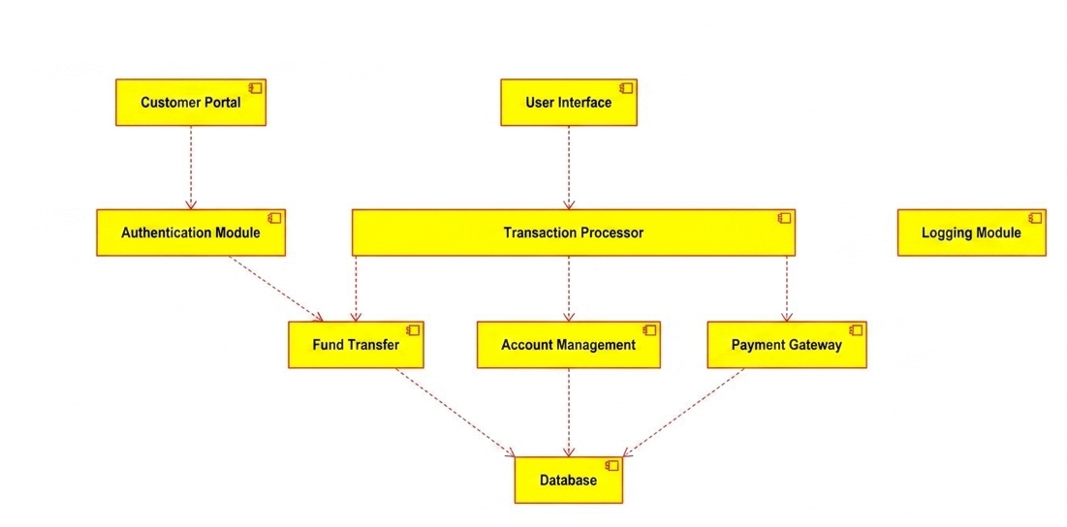
COMMUNICATION DIAGRAM:
